Jose Rodriguez
6/7/2026
CSD325 Module 1.2 Assignment

- Link to GitHub repository.
- https://github.com/jrod818/csd-325.git

- Screenshot of GitHub repository.
- 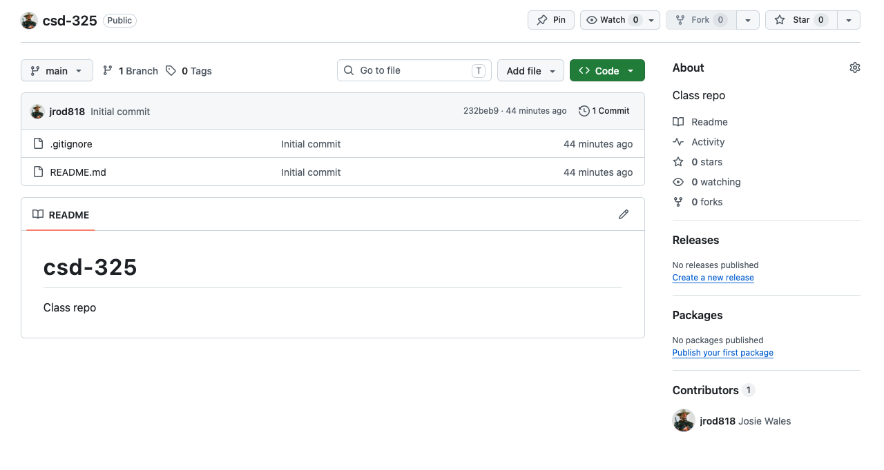
- Screenshot of local directory (properly formatted).
- 